Below is the list of service requirements from Fincantieri,

|  |  |  |  |
| --- | --- | --- | --- |
| Integration ID | From | To | Description |
| 1 | PO | SAP RI | Anagrafica Progetti |
| 2 | PO | SAP PLM | Anagrafica Deliverables, creazione e aggiornamento stato |
| 3 | SAP RI | PO | Project Data - **LoadProjectDataAsync** |
| 4 | SAP RI | PO | SAL Data - **LoadSALDataAsync** |
| 5 | SAP RI | PO | Standard Rates - **LoadStandardRatesToPOAsync** |
| 6 | SAP RI | PO | Calculation Actual Personnel cost by project (requirement was not clear, and never discussed) |
| 7 | SAP PS | PO | Cost Element master data - **LoadCostMasterDataAsync** |
| 8 | SAP PS | PO | WBS Master Data - **LoadWBSMasterDataToPOAsync** |
| 9 | SAP PS | PO | Internal Orders (alcuni progetti sono rappresentati per WBS altri per ordini interni) - **LoadInternalOrderDataToPOAsync** |
| 10 | SAP CO | PO | Costs - **LoadCostDataToPOAsync** |
| 11 | SAP HR | PO | Personnel Master Data - **LoadPersonalDataToPOAsync** |
| 12 | SAP RI | PO | Costs (costi per prestazioni esterne) – (requirement was not clear, and never discussed) |
| 13 | SAP RI | PO | Hours - **LoadHoursDataAsync** |
| 14 | SAP PLM | PO | Deliverable, aggiornamento attribute - **LoadDeliverableDataAsync** |

**1-2** -> Used to send data from PO to SAP.

**3-14** -> Used to receive data from SAP to PO.

Please check the following in the main repository of the POx

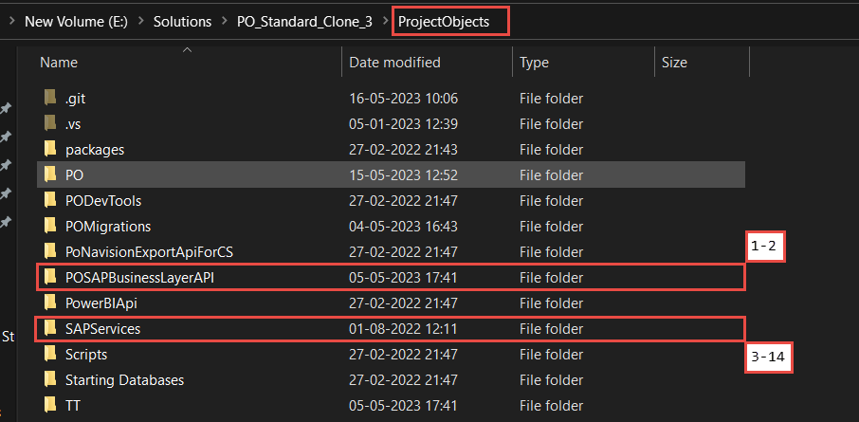

**SOAP Service (3-14)**

Open the SAPServices folder, and run the solution. SapToPoProjectData is the main service file with all the controllers/methods.

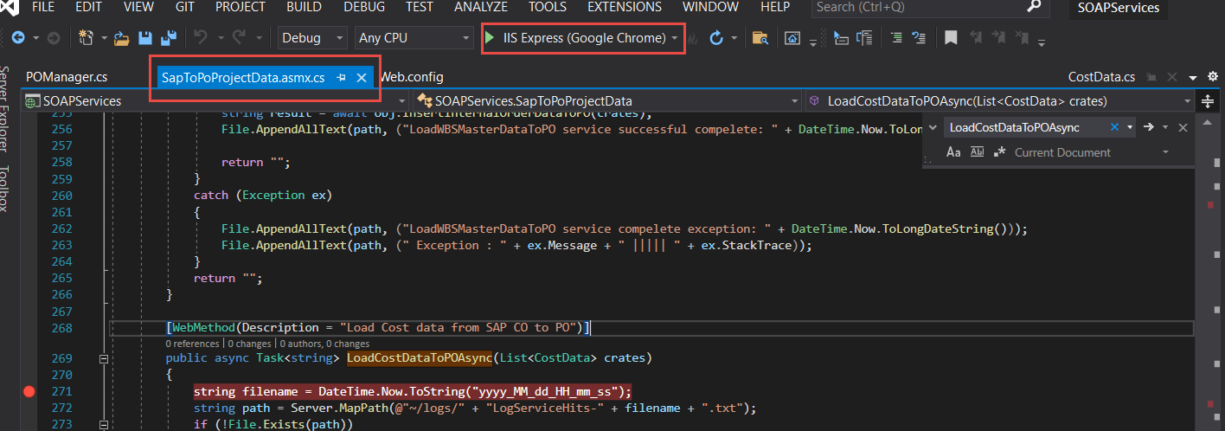

Copy the link and paste it into the SOAP UI.

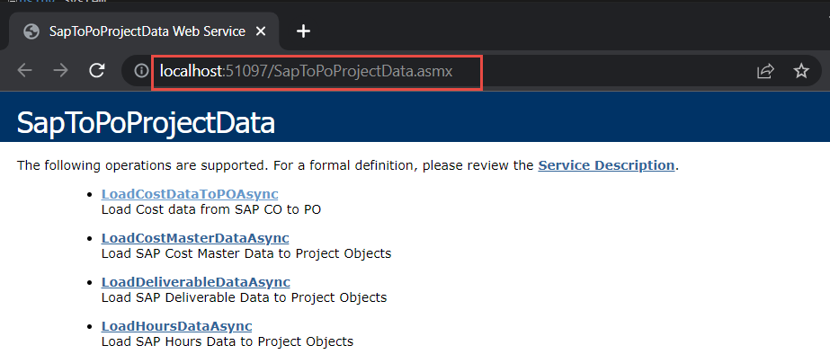

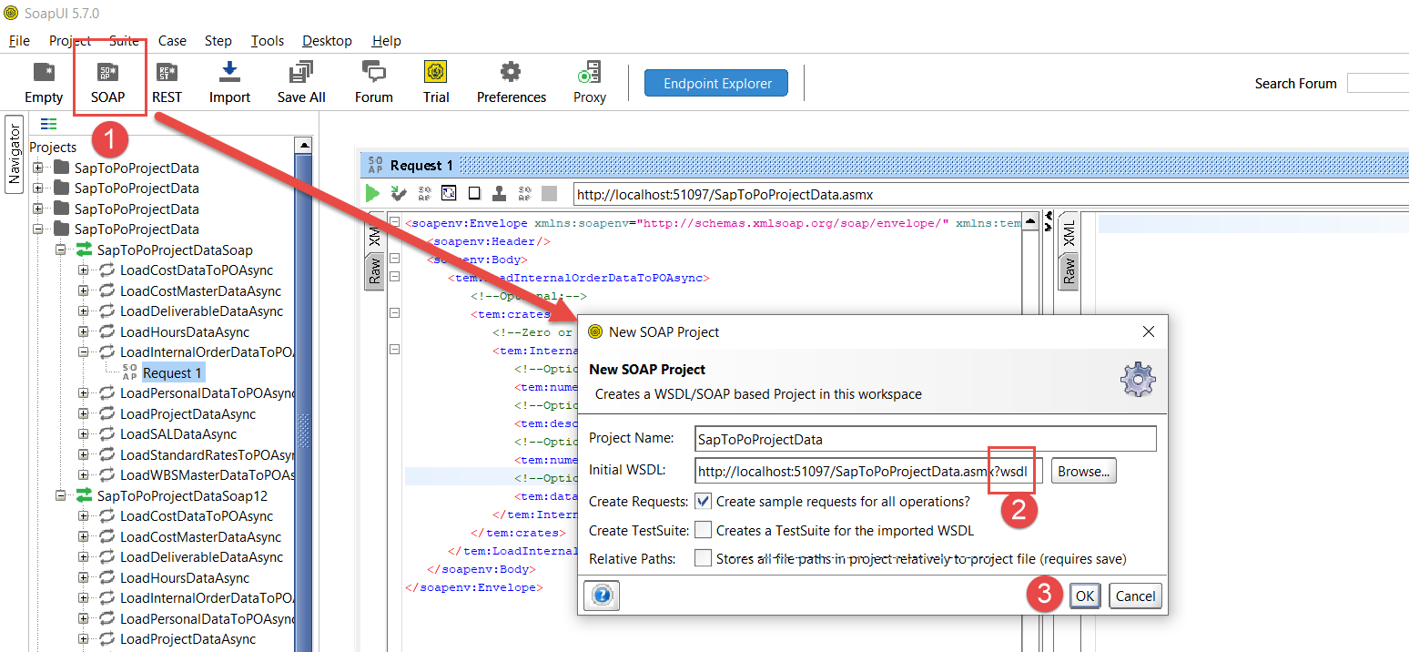

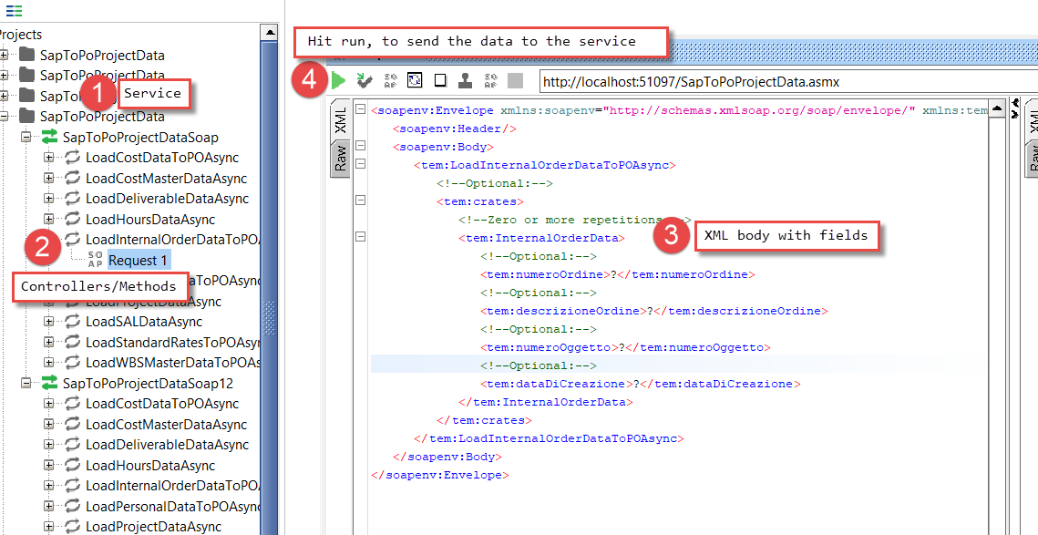

Below is the link for the SOAP service for livetrial server.

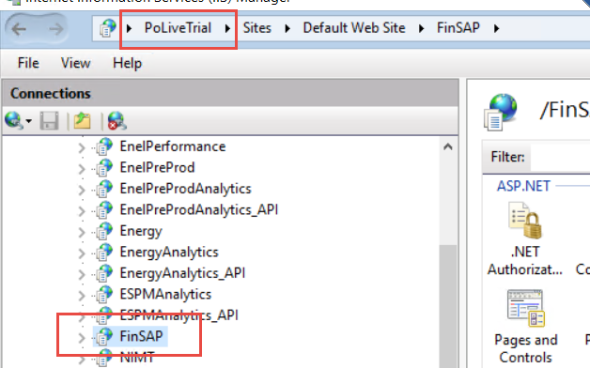

**Below is the list of tables developed:**

* SAP_TO_PO_COST_DATA
* SAP_TO_PO_COST_MASTER_STAGING_DATA
* SAP_TO_PO_DELIVERABLE_DATA
* SAP_TO_PO_HOURS_DATA
* SAP_TO_PO_WBS_INTERNAL_ORDER_DATA
* SAP_TO_PO_PERSONAL_DATA
* SAP_TO_PO_PROJ_DATA
* SAP_TO_PO_SAL_DATA
* SAP_TO_PO_STANDARD_RATE_DATA
* SAP_TO_PO_WBS_INTERNAL_ORDER_DATA
* SAP_ASCN_PO_COST_ELEMENT
* SAP_TO_PO_COST_MASTER_STAGING_DATA
* SAP_BULK_EXPORT_LOG
* PO_TO_SAP_PROJ_DATA_QUEUE
* PO_TO_SAP_HISTORY_DATA
* PO_TO_SAP_HISTORY_DATA_DELIVERABLE
* PROJ_ASCN_WBS_INTERNAL_ORDER
* SAP_TO_PO_WBS_MASTER_DATA
* SAP_COST_IMPORT_DATA
* SAP_COST_IMPORT_INFO
* SAP_COST_IMPORT_LOG
* SAP_TO_PO_COST_DATA_LOG

**API Solution (1-2) - POSAPBusinessLayerAPI**

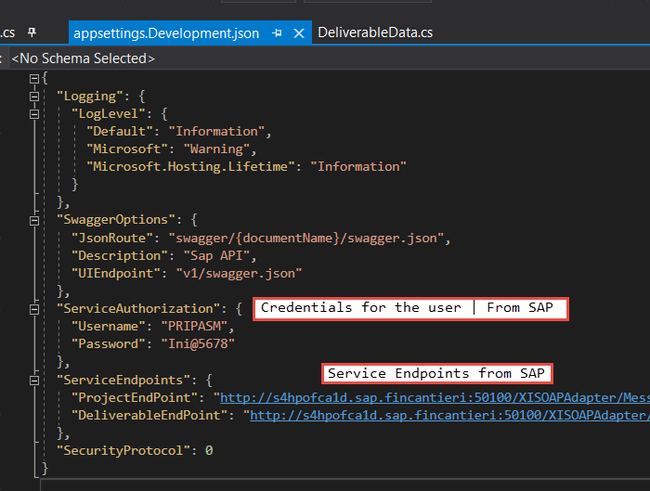

Below is the link for the web api for livetrial server.

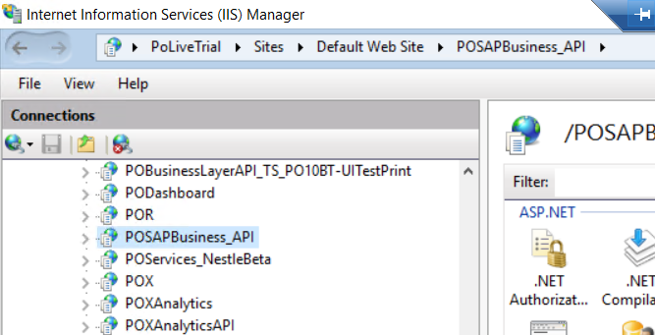

The above API is called by the stored procedures, and these procedures are set as step of a sql job.

Following is the SP used to send Project data from PO to SAP via API

exec **SendProjectDataToSAPAPI** 'http://localhost:58730/api/SAP/',-1

Following is the SP used to send deliverable data from PO to SAP via API

exec **SendDeliverableDataToSAPAPI** 'http://localhost:58730/api/SAP/',-1